Q1. RoyalStay Reservation System
class Reservation {
String guestName;
String roomType;
int floor;
double rate;

// Walk-in constructor
Reservation() {
guestName = "Walk-in Guest";
roomType = "Standard";
floor = 0;
rate = 2000;
}

// Online booking constructor
Reservation(String name, String roomType, int floor, double rate) {
this.guestName = name;
this.roomType = roomType;
this.floor = floor;
this.rate = rate;
}

// Copy constructor
Reservation(Reservation r) {
this.guestName = r.guestName;
this.roomType = r.roomType;
this.floor = r.floor;
this.rate = r.rate;
}

void display() {
System.out.println("Guest: " + guestName);
System.out.println("Room: " + roomType);
System.out.println("Floor: " + floor);
System.out.println("Rate: Rs." + rate);
System.out.println("---------------------");
}
}

public class Main {
public static void main(String[] args) {

Reservation r1 = new Reservation();

Reservation r2 = new Reservation("Arjun", "Deluxe", 3, 3500);

Reservation r3 = new Reservation(r2);
r3.guestName = "Rahul";

r1.display();
r2.display();
r3.display();
}
}

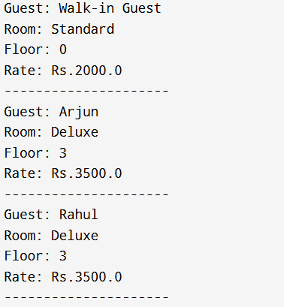
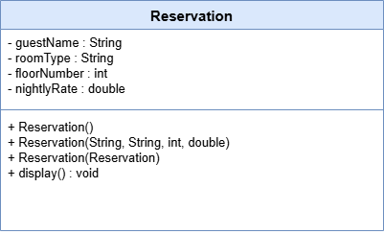
Q2. QuickBite Order System
class Order {
String item;
int quantity;
String address;
String instruction;

// Quick order
Order() {
item = "Veg Combo";
quantity = 1;
address = "To be updated";
instruction = "None";
}

// Item + quantity
Order(String item, int quantity) {
this.item = item;
this.quantity = quantity;
address = "Home Address on File";
instruction = "None";
}

// Full details
Order(String item, int quantity, String address, String instruction) {
this.item = item;
this.quantity = quantity;
this.address = address;
this.instruction = instruction;
}

void display() {
System.out.println("Item: " + item);
System.out.println("Quantity: " + quantity);
System.out.println("Address: " + address);
System.out.println("Instruction: " + instruction);
System.out.println("---------------------");
}
}

public class Main {
public static void main(String[] args) {

Order o1 = new Order();
Order o2 = new Order("Pizza", 2);
Order o3 = new Order("Burger", 3, "College Hostel", "Less spicy");

o1.display();
o2.display();
o3.display();
}
}

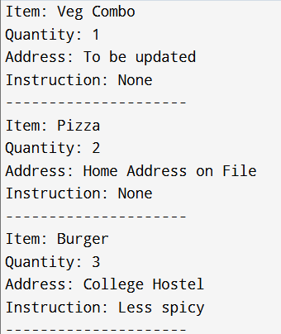
Q3. Hospital Registration (Static ID)
class Patient {

static int counter = 1001;

int id;
String name;
int age;
String ward;
String notes;

// Emergency
Patient() {
id = counter++;
name = "Unknown";
age = 0;
ward = "Emergency";
notes = "None";
}

// OPD
Patient(String name, int age, String ward, String notes) {
id = counter++;
this.name = name;
this.age = age;
this.ward = ward;
this.notes = notes;
}

// Copy constructor
Patient(Patient p) {
id = counter++;
this.name = p.name;
this.age = p.age;
this.ward = p.ward;
this.notes = p.notes;
}

void display() {
System.out.println("ID: " + id +
" Name: " + name +
" Age: " + age +
" Ward: " + ward +
" Notes: " + notes);
}
}

public class Main {
public static void main(String[] args) {

Patient p1 = new Patient();

Patient p2 = new Patient("Kumar", 35, "OPD", "Fever");

Patient camp = new Patient("Ravi", 40, "Camp", "BP High");

Patient p3 = new Patient(camp);

p1.display();
p2.display();
p3.display();
}
}

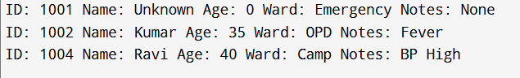
Q4. SmartGadgets Device Initialization
class Device {

String name;
String status;
String firmware;

// Assembly
Device() {
name = "SG-Device";
firmware = "v1.0";
status = "Inactive";
display();
}

// Testing
Device(String name, String firmware) {
this.name = name;
this.firmware = firmware;
status = "Inactive";
display();
}

// Customer purchase
Device(String name, String firmware, String status) {
this.name = name;
this.firmware = firmware;
this.status = status;
display();
}

void display() {
System.out.println("Device: " + name);
System.out.println("Firmware: " + firmware);
System.out.println("Status: " + status);
System.out.println("---------------------");
}
}

public class Main {
public static void main(String[] args) {

new Device();
new Device("SG-Cam", "v2.0");
new Device("SG-Light", "v3.1", "Active");
}
}
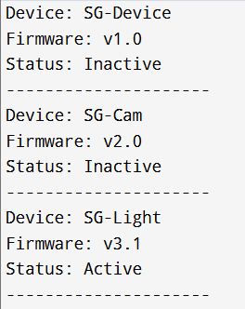
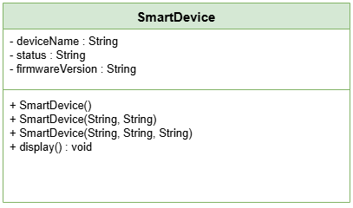
Q5. EduTrack Enrollment System
class Student {

static int rollCounter = 101;

int roll;
String name;
String course;

// Default
Student() {
roll = 0;
name = "Unassigned";
course = "General";
}

// Enrollment
Student(String name, String course) {
roll = rollCounter++;
this.name = name;
this.course = course;
}

// Copy (Transfer)
Student(Student s) {
roll = rollCounter++;
this.name = s.name;
this.course = s.course;
}

void display() {
System.out.println("Roll: " + roll +
" Name: " + name +
" Course: " + course);
}
}

public class Main {
public static void main(String[] args) {

Student s1 = new Student();

Student s2 = new Student("Anita", "Java");

Student s3 = new Student(s2);

s1.display();
s2.display();
s3.display();
}
}

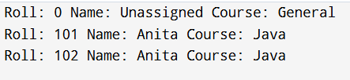
Q6. Zoo System
class Animal {
String name;
int age;
String diet;

Animal(String name, int age, String diet) {
this.name = name;
this.age = age;
this.diet = diet;
}

void eat() {
System.out.println(name + " is eating");
}

void sleep() {
System.out.println(name + " is sleeping");
}

void display() {
System.out.println("Name: " + name + " Age: " + age + " Diet: " + diet);
}
}

class Mammal extends Animal {
String furColor;

Mammal(String name, int age, String diet, String furColor) {
super(name, age, diet);
this.furColor = furColor;
}

void run() {
System.out.println(name + " is running");
}
}

class Bird extends Animal {
double wingspan;

Bird(String name, int age, String diet, double wingspan) {
super(name, age, diet);
this.wingspan = wingspan;
}

void fly() {
System.out.println(name + " is flying");
}
}

class Reptile extends Animal {
boolean venomous;

Reptile(String name, int age, String diet, boolean venomous) {
super(name, age, diet);
this.venomous = venomous;
}

void crawl() {
System.out.println(name + " is crawling");
}
}

public class Main {
public static void main(String[] args) {

Mammal m = new Mammal("Lion", 5, "Carnivore", "Golden");
Bird b = new Bird("Eagle", 3, "Carnivore", 2.5);
Reptile r = new Reptile("Snake", 2, "Carnivore", true);

m.display();
m.run();

b.display();
b.fly();

r.display();
r.crawl();
}
}

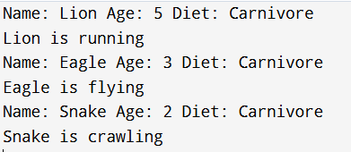
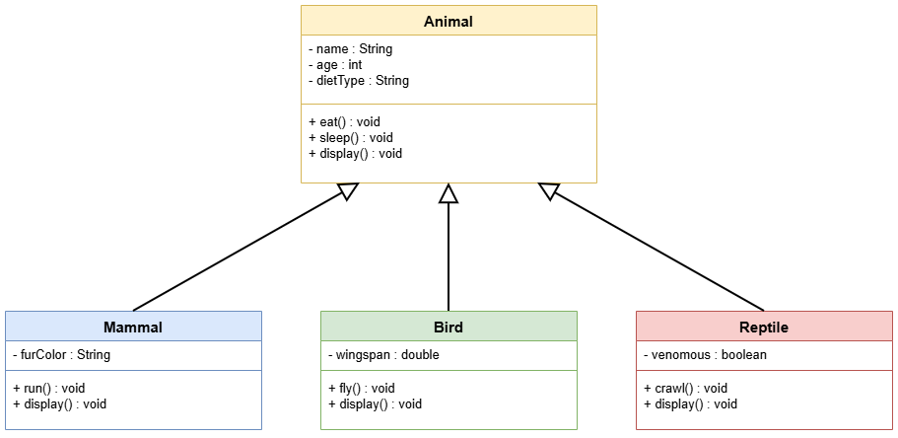
Q7. University System
class Person {
String name;
int id;

Person(String name, int id) {
this.name = name;
this.id = id;
}
}

class Student extends Person {
String department;
double cgpa;

Student(String name, int id, String dept, double cgpa) {
super(name, id);
this.department = dept;
this.cgpa = cgpa;
}
}

class ResearchScholar extends Student {
String topic;
String guide;

ResearchScholar(String name, int id, String dept, double cgpa,
String topic, String guide) {
super(name, id, dept, cgpa);
this.topic = topic;
this.guide = guide;
}

void display() {
System.out.println("Name: " + name);
System.out.println("ID: " + id);
System.out.println("Department: " + department);
System.out.println("CGPA: " + cgpa);
System.out.println("Topic: " + topic);
System.out.println("Guide: " + guide);
}
}

public class Main {
public static void main(String[] args) {

ResearchScholar rs =
new ResearchScholar("Anita", 101, "CSE", 8.9,
"AI Optimization", "Dr. Rao");

rs.display();
}
}

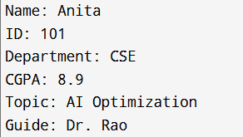
Q8. Transit Fleet System
class Vehicle {
String regNo;
String fuel;
int speed;

Vehicle(String regNo, String fuel, int speed) {
this.regNo = regNo;
this.fuel = fuel;
this.speed = speed;
}

void start() {
System.out.println(regNo + " started");
}

void stop() {
System.out.println(regNo + " stopped");
}
}

class Bus extends Vehicle {
int capacity;

Bus(String regNo, String fuel, int speed, int capacity) {
super(regNo, fuel, speed);
this.capacity = capacity;
}

void display() {
System.out.println("Bus " + regNo + " Capacity: " + capacity);
}
}

class Truck extends Vehicle {
int load;

Truck(String regNo, String fuel, int speed, int load) {
super(regNo, fuel, speed);
this.load = load;
}

void display() {
System.out.println("Truck " + regNo + " Load: " + load + " tons");
}
}

class Van extends Vehicle {
boolean refrigeration;

Van(String regNo, String fuel, int speed, boolean refrigeration) {
super(regNo, fuel, speed);
this.refrigeration = refrigeration;
}

void display() {
System.out.println("Van " + regNo + " Refrigeration: " + refrigeration);
}
}

public class Main {
public static void main(String[] args) {

Bus b = new Bus("KA01", "Diesel", 80, 50);
Truck t = new Truck("KA02", "Diesel", 70, 10);
Van v = new Van("KA03", "Petrol", 90, true);

b.display();
t.display();
v.display();
}
}

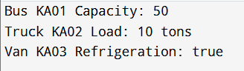
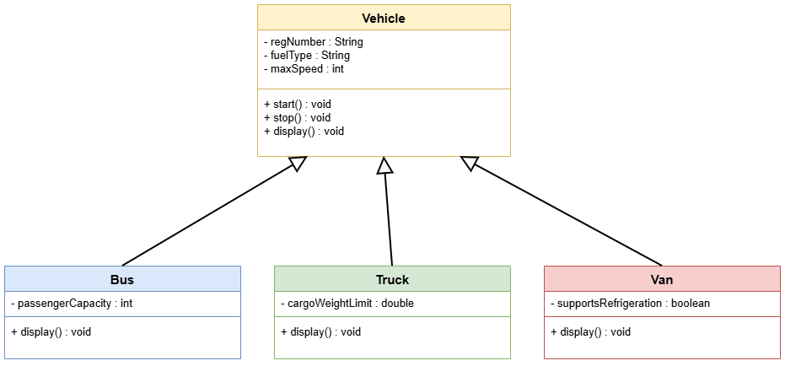
Q9. Company Structure
class Employee {
String name;
int id;
double salary;

Employee(String name, int id, double salary) {
this.name = name;
this.id = id;
this.salary = salary;
}
}

class TeamLead extends Employee {
int teamSize;
double bonus;

TeamLead(String name, int id, double salary,
int teamSize, double bonus) {
super(name, id, salary);
this.teamSize = teamSize;
this.bonus = bonus;
}
}

class ProjectManager extends TeamLead {
String project;
double budget;

ProjectManager(String name, int id, double salary,
int teamSize, double bonus,
String project, double budget) {
super(name, id, salary, teamSize, bonus);
this.project = project;
this.budget = budget;
}

void display() {
System.out.println("Name: " + name);
System.out.println("ID: " + id);
System.out.println("Salary: " + salary);
System.out.println("Team Size: " + teamSize);
System.out.println("Bonus: " + bonus);
System.out.println("Project: " + project);
System.out.println("Budget: " + budget);
}
}

public class Main {
public static void main(String[] args) {

ProjectManager pm =
new ProjectManager("Rahul", 201, 90000,
8, 15000,
"Bank App", 500000);

pm.display();
}
}

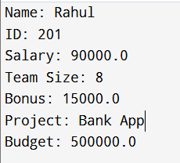
Q10. MeloTune Content System
class Content {
String title;
int duration;
String artist;

Content(String title, int duration, String artist) {
this.title = title;
this.duration = duration;
this.artist = artist;
}

void play() {
System.out.println("Playing " + title);
}
}

class Song extends Content {
String genre;

Song(String title, int duration, String artist, String genre) {
super(title, duration, artist);
this.genre = genre;
}

void display() {
System.out.println("Song: " + title + " Genre: " + genre);
}
}

class Podcast extends Content {
int episode;

Podcast(String title, int duration, String artist, int episode) {
super(title, duration, artist);
this.episode = episode;
}

void display() {
System.out.println("Podcast: " + title + " Episode: " + episode);
}
}

class Audiobook extends Content {
int chapters;

Audiobook(String title, int duration, String artist, int chapters) {
super(title, duration, artist);
this.chapters = chapters;
}

void display() {
System.out.println("Audiobook: " + title + " Chapters: " + chapters);
}
}

public class Main {
public static void main(String[] args) {

Song s = new Song("Melody", 4, "Arjun", "Pop");
Podcast p = new Podcast("TechTalk", 30, "Host A", 5);
Audiobook a = new Audiobook("Java Guide", 120, "Author B", 12);

s.display();
p.display();
a.display();
}
}
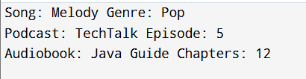
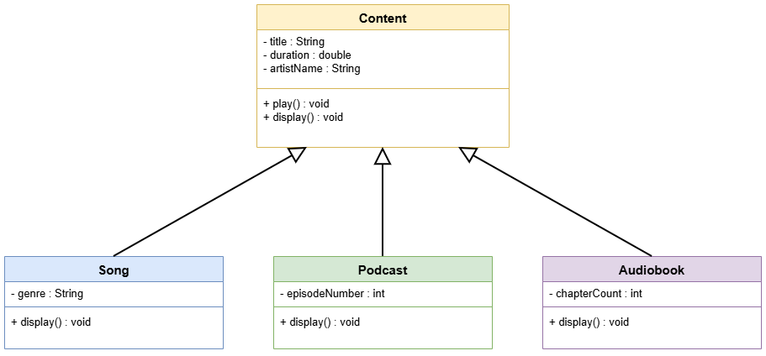

11.Library Management System
Actors:
- Visitor (non-member)
- Member (registered user)
- Librarian
- Admin
Use Cases:
- Visitor: search books, browse catalog
- Member: borrow books, return books, reserve books
- Librarian: manage books, handle member registration
- Admin: manage users, generate reports
Relationships:
- Member is a Visitor → Generalization
Q12. HealthFirst Hospital System
Actors:
- Patient
- Doctor
- Receptionist
- System
Use Cases:
- Patient: register, search doctor, book appointment, cancel appointment, view appointment
- Doctor: schedule, prescribe medication, refer patient
- Receptionist: assist booking, manage walk-ins
- System: send notifications, reminders
Relationships:
- Booking appointment automatically triggers notification → <<include>>
- Optional actions like follow-up → <<extend>>

Q13. CampusEats Food Ordering System
Actors:
- Customer
- Kitchen Staff
- Delivery Person
- System
Use Cases:
- Customer: browse menu, add to cart, place order, pay, track order
- Kitchen Staff: receive order, update status, manage menu
- Delivery Person: pickup order, deliver order
- System: handle payment failures, retry orders, cancel order if needed
Relationships:
- Placing order requires adding to cart → <<include>>
- Payment failure triggers retry/cancel → <<extend>>

Q14. ParkSmart Parking System
Actors:
- Driver
- Parking Sensor
- Attendant
- Admin
Use Cases:
- Driver: enter, get token, pay for parking
- Sensor/System: read license plate, assign slot, calculate fee
- Attendant: override system, maintenance
- Admin: configure rates, generate reports
Relationships:
- Simple associations only; no include/extend
Q15. QuizArena Examination Portal
Actors:
- Student
- Instructor
- Admin
- System
Use Cases:
- Student: register, login, view tests, attempt test, view results
- Instructor: create test, add questions, set duration, publish test, view analytics
- Admin: manage accounts, reset password
- System: auto-submit test, generate certificate
Relationships:
- Attempt test → must include login → <<include>>
- Create test → must include add questions, set duration → <<include>>
- Timer expires → auto-submit test → <<extend>>
- Score > 90% → generate certificate → <<extend>>
Q16. SparkleWash — Car Wash Service
class Car {
String licensePlate;
String ownerName;
String carModel;
String color;

Car(String licensePlate, String ownerName, String carModel, String color) {
this.licensePlate = licensePlate;
this.ownerName = ownerName;
this.carModel = carModel;
this.color = color;
}

void exteriorWash() {
displaySummary("Basic Exterior Wash");
}

void interiorVacuum() {
displaySummary("Interior Vacuum Cleaning");
}

void fullDetailService() {
displaySummary("Full Detail Service");
}

void displaySummary(String service) {
System.out.println("----- Service Summary -----");
System.out.println("License Plate : " + licensePlate);
System.out.println("Owner : " + ownerName);
System.out.println("Model : " + carModel);
System.out.println("Color : " + color);
System.out.println("Service Done : " + service);
System.out.println();
}
}

public class Main {
public static void main(String[] args) {

Car c1 = new Car("TS09AB1234", "Ravi", "Swift", "White");
Car c2 = new Car("AP05CD5678", "Sneha", "i20", "Red");
Car c3 = new Car("KA01EF9012", "Arjun", "Creta", "Black");

c1.exteriorWash();
c2.interiorVacuum();
c3.fullDetailService();
}
}

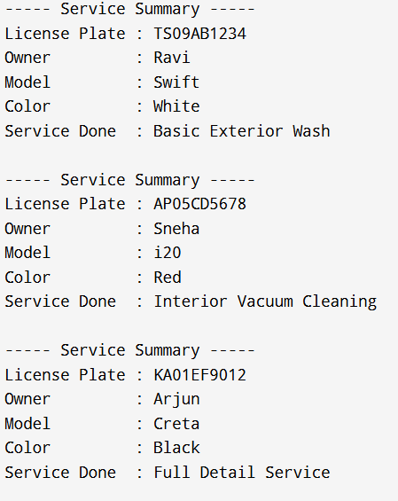
Class to identify: Car
Attributes:
- registrationNumber: String
- ownerName: String
- model: String
- color: String
Methods:
- basicExteriorWash(): void
- interiorVacuum(): void
- fullDetail(): void
- displaySummary(): void
Q17. CineNova — Movie Ticket System
class Screening {
String movieName;
String showtime;
int screenNumber;
int availableSeats;

Screening(String movieName, String showtime, int screenNumber, int availableSeats) {
this.movieName = movieName;
this.showtime = showtime;
this.screenNumber = screenNumber;
this.availableSeats = availableSeats;
}

void bookTickets(int count) {
if (count <= availableSeats) {
availableSeats -= count;
System.out.println(count + " tickets booked for " + movieName);
} else {
System.out.println("Not enough seats for " + movieName);
}
}

void cancelBooking(int count) {
availableSeats += count;
System.out.println(count + " tickets cancelled for " + movieName);
}

void display() {
System.out.println("Movie: " + movieName);
System.out.println("Showtime: " + showtime);
System.out.println("Screen: " + screenNumber);
System.out.println("Available Seats: " + availableSeats);
System.out.println("----------------------------");
}
}

public class Main {
public static void main(String[] args) {

Screening s1 = new Screening("Pushpa2", "7PM", 1, 100);
Screening s2 = new Screening("Salaar", "8PM", 2, 80);

s1.bookTickets(5);
s1.bookTickets(3);
s2.bookTickets(10);

s1.cancelBooking(2);

s1.display();
s2.display();
}
}
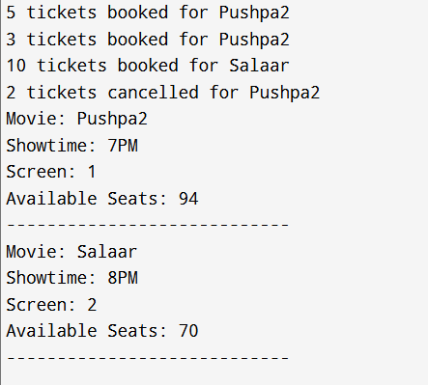

Q18. FitLife — Gym Member System

class GymMember {
int id;
String name;
int age;
String membership;
double fee;

GymMember(int id, String name, int age, String membership, double fee) {
this.id = id;
this.name = name;
this.age = age;
this.membership = membership;
this.fee = fee;
}

void display() {
System.out.println("ID: " + id);
System.out.println("Name: " + name);
System.out.println("Age: " + age);
System.out.println("Membership: " + membership);
System.out.println("Fee: " + fee);

if(age < 25)
System.out.println("Youth Discount: YES");
else
System.out.println("Youth Discount: NO");

System.out.println();
}
}

public class Main {
public static void main(String[] args) {

GymMember m1 = new GymMember(1,"Aarav",22,"Monthly",1000);
GymMember m2 = new GymMember(2,"Neha",30,"Quarterly",2500);
GymMember m3 = new GymMember(3,"Karthik",19,"Annual",8000);
GymMember m4 = new GymMember(4,"Meera",27,"Monthly",1000);

m1.display();
m2.display();
m3.display();
m4.display();
}
}

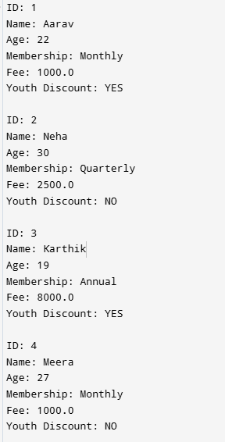
Q19. BrightSmile — Dental Clinic

class Patient {
int id;
String name;
String contact;
String procedure;

Patient(int id,String name,String contact,String procedure){
this.id=id;
this.name=name;
this.contact=contact;
this.procedure=procedure;
}

int getCost(){
switch(procedure){
case "Cleaning": return 500;
case "Filling": return 1500;
case "Extraction": return 2000;
case "Root Canal": return 8000;
default: return 0;
}
}

void display(){
System.out.println("Patient ID: "+id);
System.out.println("Name: "+name);
System.out.println("Contact: "+contact);
System.out.println("Procedure: "+procedure);
System.out.println("Cost: "+getCost());
System.out.println();
}
}

public class Main {
public static void main(String[] args) {

Patient p1 = new Patient(1,"Ravi","9991112222","Cleaning");
Patient p2 = new Patient(2,"Sita","9991112223","Filling");
Patient p3 = new Patient(3,"Amit","9991112224","Extraction");
Patient p4 = new Patient(4,"Priya","9991112225","Root Canal");
Patient p5 = new Patient(5,"Kiran","9991112226","Cleaning");

p1.display();
p2.display();
p3.display();
p4.display();
p5.display();
}
}

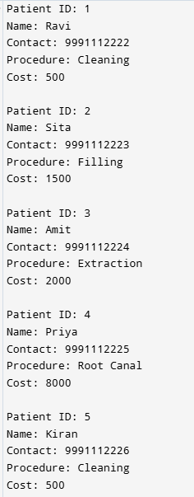
Class to identify: DentalPatient
Attributes:
- patientId: int
- name: String
- contactNumber: String
- procedure: String
Methods:
- getEstimatedCost(): int
- display(): void
Q20. UrbanGarden — Plant Inventory
class Plant {
int id;
String name;
String type;
double price;
int stock;

Plant(int id,String name,String type,double price,int stock){
this.id=id;
this.name=name;
this.type=type;
this.price=price;
this.stock=stock;
}

void display(){
System.out.println("ID: "+id);
System.out.println("Name: "+name);
System.out.println("Type: "+type);
System.out.println("Price: "+price);
System.out.println("Stock: "+stock);
System.out.println();
}

void sell(int qty){
if(qty>stock){
System.out.println("Sale cannot be processed for "+name);
}else{
stock-=qty;
System.out.println(qty+" sold for "+name);
}
}

void restock(int qty){
stock+=qty;
System.out.println(qty+" added to "+name);
}
}

public class Main {
public static void main(String[] args) {

Plant p1 = new Plant(1,"MoneyPlant","Indoor",250,20);
Plant p2 = new Plant(2,"Rose","Outdoor",150,10);
Plant p3 = new Plant(3,"AloeVera","Indoor",200,5);

p1.display();
p2.display();
p3.display();

p1.sell(3);
p3.sell(8);
p2.restock(15);

p1.display();
p2.display();
p3.display();
}
}

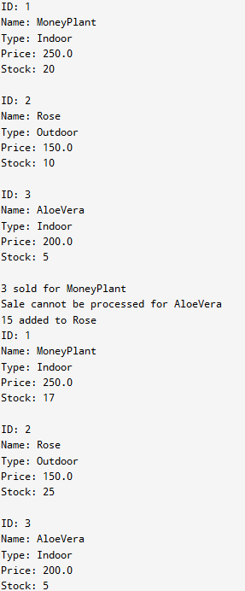
Q21. Bonus Calculation System
public class Main {
public static void main(String[] args) {

String name = "Ramesh";
double salary = 40000;
int experience = 7;
String department = "Hazardous";

double bonusPercent;

if (experience < 2)
bonusPercent = 0;
else if (experience <= 5)
bonusPercent = 10;
else if (experience <= 10)
bonusPercent = 20;
else
bonusPercent = 35;

double bonus = salary * bonusPercent / 100;

if (department.equalsIgnoreCase("Hazardous"))
bonus += 5000;

System.out.println("Name: " + name);
System.out.println("Salary: " + salary);
System.out.println("Experience: " + experience);
System.out.println("Department: " + department);
System.out.println("Total Bonus: " + bonus);
}
}

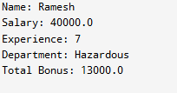
Q22. Driving License Eligibility
public class Main {
public static void main(String[] args) {

String name = "Ravi";
int age = 19;
String type = "Car";

if (type.equals("Car")) {
if (age >= 18)
System.out.println("Eligible for Car License");
else
System.out.println("Not Eligible for Car License");
}
else if (type.equals("Commercial")) {
if (age >= 20)
System.out.println("Eligible for Commercial License");
else
System.out.println("Not Eligible for Commercial License");
}
else if (type.equals("Motorcycle")) {
if (age >= 16)
System.out.println("Eligible for Motorcycle License");
else
System.out.println("Not Eligible for Motorcycle License");
}
else {
System.out.println("Invalid License Type");
}
}
}

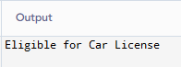
Q23. Café Billing System
public class Main {
public static void main(String[] args) {

int category = 5;
int quantity = 4;

int price = 0;

switch(category) {
case 1: price = 100; break;
case 2: price = 200; break;
case 3: price = 400; break;
case 4: price = 150; break;
case 5: price = 600; break;
default:
System.out.println("Invalid Category");
return;
}

double total = price * quantity;
double discount = 0;

if (total > 2000)
discount = total * 0.20;
else if (total > 1000)
discount = total * 0.10;

double finalBill = total - discount;

System.out.println("Total: " + total);
System.out.println("Discount: " + discount);
System.out.println("Final Bill: " + finalBill);
}
}

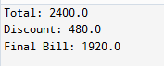

Q24. Student Grade System
public class Main {
public static void main(String[] args) {

int marks = 78;

if (marks >= 90)
System.out.println("Grade: Outstanding");
else if (marks >= 75)
System.out.println("Grade: Excellent");
else if (marks >= 60)
System.out.println("Grade: Good");
else if (marks >= 45)
System.out.println("Grade: Satisfactory");
else
System.out.println("Grade: Needs Improvement");
}
}

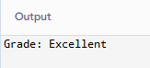
Q25. Telecom Billing
public class Main {
public static void main(String[] args) {

int calls = 120;
int sms = 80;
double data = 3.5;

double callCharge = 0;

if (calls > 50 && calls <= 150)
callCharge = (calls - 50) * 1;
else if (calls > 150)
callCharge = 100 * 1 + (calls - 150) * 1.5;

double smsCharge = sms * 0.5;

double dataCharge = 0;
if (data > 1 && data <= 5)
dataCharge = (data - 1) * 50;
else if (data > 5)
dataCharge = 4 * 50 + (data - 5) * 30;

double total = callCharge + smsCharge + dataCharge;

System.out.println("Call Charge: " + callCharge);
System.out.println("SMS Charge: " + smsCharge);
System.out.println("Data Charge: " + dataCharge);
System.out.println("Total Bill: " + total);
}
}

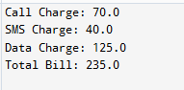
Q26.
class BankAccount {
private int accountNumber; // cannot be accessed directly
private double balance; // cannot be accessed directly
protected String accountHolderName; // can be accessed within class & subclasses

public static final double BANK_INTEREST_RATE = 7.5; // constant for all accounts

public BankAccount(int accountNumber, String accountHolderName, double balance) {
this.accountNumber = accountNumber;
this.accountHolderName = accountHolderName;
this.balance = balance;
}

public int getAccountNumber() { return accountNumber; }
public double getBalance() { return balance; }

public void deposit(double amount) { balance += amount; }

public void withdraw(double amount) {
if (amount <= balance) balance -= amount;
else System.out.println("Insufficient funds!");
}

public double calculateInterest() {
return balance * (BANK_INTEREST_RATE / 100);
}

public void display() {
System.out.println("Account No: " + accountNumber);
System.out.println("Holder Name: " + accountHolderName);
System.out.println("Balance: " + balance);
System.out.println("Interest Rate: " + BANK_INTEREST_RATE + "%");
}
}

class SavingsAccount extends BankAccount {
public SavingsAccount(int accountNumber, String name, double balance) {
super(accountNumber, name, balance);
}

@Override
public double calculateInterest() {
return getBalance() * (BANK_INTEREST_RATE / 100) * 1.1; // 10% extra
}
}

class CurrentAccount extends BankAccount {
public CurrentAccount(int accountNumber, String name, double balance) {
super(accountNumber, name, balance);
}
}

public class Main {
public static void main(String[] args) {
SavingsAccount sAcc = new SavingsAccount(101, "Alice", 10000);
CurrentAccount cAcc = new CurrentAccount(102, "Bob", 20000);

sAcc.deposit(500);
cAcc.withdraw(5000);

sAcc.display();
System.out.println("Savings Account Interest: " + sAcc.calculateInterest());
System.out.println("----------------------------");
cAcc.display();
System.out.println("Current Account Interest: " + cAcc.calculateInterest());
}
}

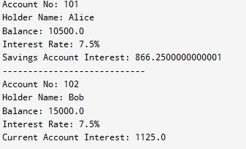

Q27.

class Student {
private String aadhaarNumber; // sensitive
protected int internalMarks; // accessible in class & subclasses
public String name;
public int rollNumber;

public static final String SCHOOL_MOTTO = "Knowledge is Power";
public static int totalStudents = 0;

public Student(String name, int rollNumber, String aadhaarNumber, int marks) {
this.name = name;
this.rollNumber = rollNumber;
this.aadhaarNumber = aadhaarNumber;
this.internalMarks = marks;
totalStudents++;
}

public void displayStudentInfo() {
System.out.println("Name: " + name);
System.out.println("Roll Number: " + rollNumber);
System.out.println("Internal Marks: " + internalMarks);
}
}

public class Main {
public static void main(String[] args) {
Student s1 = new Student("Alice", 101, "1234-5678-9012", 85);
Student s2 = new Student("Bob", 102, "2345-6789-0123", 90);
Student s3 = new Student("Charlie", 103, "3456-7890-1234", 78);

s1.displayStudentInfo();
System.out.println("School Motto: " + Student.SCHOOL_MOTTO);
System.out.println("-------------------");
s2.displayStudentInfo();
System.out.println("-------------------");
s3.displayStudentInfo();
System.out.println("Total Students: " + Student.totalStudents);
}
}
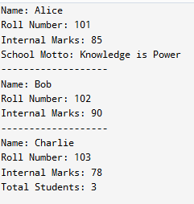

Q28.
class Shipment {
protected int shipmentId;
protected double weight;
protected String destination;
public static final String COMPANY_CODE = "LOGI"; // constant for company

public Shipment(int shipmentId, double weight, String destination) {
this.shipmentId = shipmentId;
this.weight = weight;
this.destination = destination;
}

// This will be overridden in child classes
public double calculateShippingCost() {
return 0;
}

// Static utility method
public static String generateTrackingNumber(int shipmentId) {
return COMPANY_CODE + shipmentId;
}

public void displayShipment() {
System.out.println("Shipment ID: " + shipmentId);
System.out.println("Destination: " + destination);
System.out.println("Weight: " + weight + " kg");
}
}

class DomesticShipment extends Shipment {
public DomesticShipment(int shipmentId, double weight, String destination) {
super(shipmentId, weight, destination);
}

@Override
public double calculateShippingCost() {
return weight * 50; // Domestic cost formula
}
}

class InternationalShipment extends Shipment {
public InternationalShipment(int shipmentId, double weight, String destination) {
super(shipmentId, weight, destination);
}

@Override
public double calculateShippingCost() {
return (weight * 200) + 1000; // International cost formula
}
}

public class Main {
public static void main(String[] args) {
DomesticShipment d1 = new DomesticShipment(101, 10, "Delhi");
InternationalShipment i1 = new InternationalShipment(201, 5, "London");

// Display Domestic Shipment
d1.displayShipment();
System.out.println("Domestic Shipping Cost: Rs " + d1.calculateShippingCost());
System.out.println("Tracking Number: " + Shipment.generateTrackingNumber(d1.shipmentId));
System.out.println("---------------------------");

// Display International Shipment
i1.displayShipment();
System.out.println("International Shipping Cost: Rs " + i1.calculateShippingCost());
System.out.println("Tracking Number: " + Shipment.generateTrackingNumber(i1.shipmentId));
}
}
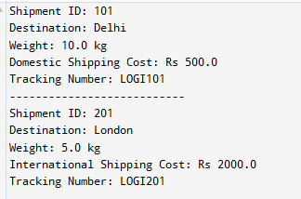
Classes:
- Abstract: Shipment
- Concrete: DomesticShipment, InternationalShipment
Parent Class (Abstract): Shipment
- Attributes: shipmentId: int, weight: double, destination: String, COMPANY_CODE: static final String
- Methods: calculateShippingCost(): double {abstract}, generateTrackingNumber(): static String
Child Classes:
- DomesticShipment → calculateShippingCost(): weight × 50
- InternationalShipment → calculateShippingCost(): weight × 200 + 1000
Q29.
class Sensor {
public int sensorId; // readable anywhere
protected String location; // accessible in class/package
private String calibrationKey; // private
public double reading; // public

public static final String UNIT = "Celsius"; // constant
public static int activeSensorCount = 0; // shared counter

public Sensor(int sensorId, String location, String calibrationKey, double reading) {
this.sensorId = sensorId;
this.location = location;
this.calibrationKey = calibrationKey;
this.reading = reading;
activeSensorCount++;
}

public void displaySensor() {
System.out.println("Sensor ID: " + sensorId);
System.out.println("Location: " + location);
System.out.println("Reading: " + reading + " " + UNIT);
// cannot access calibrationKey outside class
}

public static double convertCelsiusToFahrenheit(double celsius) {
return (celsius * 9/5) + 32;
}
}

public class Main {
public static void main(String[] args) {
Sensor s1 = new Sensor(1, "Rooftop", "key123", 28.5);
Sensor s2 = new Sensor(2, "Lobby", "key234", 25.0);
Sensor s3 = new Sensor(3, "Server Room", "key345", 22.8);

s1.displaySensor();
System.out.println("Fahrenheit: " + Sensor.convertCelsiusToFahrenheit(s1.reading));
System.out.println("-------------------");
s2.displaySensor();
System.out.println("Fahrenheit: " + Sensor.convertCelsiusToFahrenheit(s2.reading));
System.out.println("-------------------");
s3.displaySensor();
System.out.println("Active Sensors: " + Sensor.activeSensorCount);
}
}
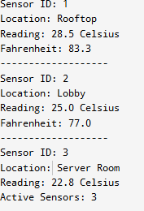
Classes to identify:
- Main class: Sensor (all functionality in a single class)
Attributes to find:
- sensorId: int → readable anywhere → public
- location: String → accessible in package → protected
- calibrationKey: String → private to class → private
- reading: double → public
- UNIT: String → constant, same for all → public static final
- activeSensorCount: int → shared among all → public static
Methods to find:
- displaySensor(): void → prints details (cannot show private calibrationKey outside class)
- convertCelsiusToFahrenheit(double celsius): double → static method, callable without object
Q30.
abstract class Artifact {
String name;

Artifact(String name) {
this.name = name;
}

abstract void showDetails();
}

class Painting extends Artifact {
String painter;

Painting(String name, String painter) {
super(name);
this.painter = painter;
}

void showDetails() {
System.out.println("Painting: " + name);
System.out.println("Painter: " + painter);
}
}

class Sculpture extends Artifact {
String material;

Sculpture(String name, String material) {
super(name);
this.material = material;
}

void showDetails() {
System.out.println("Sculpture: " + name);
System.out.println("Material: " + material);
}
}

public class Main {
public static void main(String[] args) {

Artifact a1 = new Painting("Nature Art", "Ramesh");
Artifact a2 = new Sculpture("Stone Idol", "Granite");

a1.showDetails();
a2.showDetails();
}
}

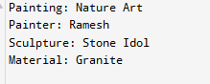

Classes to identify:
- Parent class: Artifact (general concept)
- Child classes: Painting, Sculpture

Parent Class (Artifact):
- Attributes common to all artifacts: artifactId, name, originCountry
- Constant for entire museum: ENTRY_FEE → static final
- Shared counter: totalArtifacts → static
- Methods: displayDescription() → implemented normally (can be overridden in children)

Child Classes:
- Painting: adds medium
- Sculpture: adds material

